Final report
Strategiskt Verktyg för Cirkulär Omställning

Project period: October 2017 - December 2019
Project number: 45315-1

 | Date | Dnr
 | 2019-12-20 | 2017-011191
 |  | Project number
 |  | 45315-1

Strategiskt Verktyg för Cirkulär Omställning

Strategic tool for circular conversion

Title – Swedish
Strategiskt Verktyg för Cirkulär Omställning
Title – English
Strategic tool for circular conversion
University/company
Chalmers Industriteknik (CIT)
Address
Sven Hultins Plats 1, 412 58 Göteborg
Name of project manager
Klas Cullbrand (CIT), Patricia van Loon (CIT)
Name of other participants
Joan Torres (CIT), Max Björkman (CIT), Evalena Blomqvist (RISE), Fredric Norefjäll (RISE), Haben Tekie (RISE), Elena Talalasova (RISE), David Lamm (BOID), Thure Waller (BOID)
Keywords:
Circular economy, value-case methodology, transition, collaboration, tool

Foreword
The ’Strategic Tool for Circular Conversion’ project, or SVCO in short, is a collaboration between Chalmers Industriteknik and RISE Research Institute Sweden and is funded by Re:Source and received co-finance from Mistra Stiftelsen för miljöstrategisk forskning.
Table of content
Swedish summary 3
English summary 3
Introduction and background 4
Implementation 5
Results and discussion 6
Conclusion and next step 8
Communication 8
References 9
Attachments 9

Swedish summary
Att bli mer cirkulär som företag är vanligtvis inte något man kan göra ensam utan att involvera andra. Till exempel, att öka andelen återvunnet material i en produkt kräver både kundens godkännande av denna förändring liksom en leverantör som kan leverera det återvunna materialet. Det kommer också att påverka produktionen av det jungfruliga materialet, återvinnare och alla andra partier däremellan. Var och en av dem kan ha ekonomiska, miljömässiga och / eller sociala värden för att stödja (eller inte) övergången, vissa gynnar mer än andra. Verktyget som utvecklats i detta projekt, som bygger på ”Value Case Methodology” utvecklat av TNO, har som syfte att belysa de positiva och mindre positiva aspekterna för varje aktör i en viss hållbarhetsprocess och skapar en miljö där dessa aspekter kan diskuteras öppet i ett försöka att hitta en lösning som fungerar för hela värdekedjan. Testresultaten har visat att verktyget är värdefullt och gör det möjligt för aktörer i en värdekedja att gå vidare med att diskutera och implementera en mer cirkulär och hållbar värdekedja.

English summary
Becoming more circular as company is usually not something that one can do alone without involving others. For example, increasing the share of recycled material in a product requires both customer acceptance of this change as well as a supplier who can deliver the recycled material. It will also affect the production of the virgin material, the recyclers, and any other party in between. Each of them might have economic, environmental, and/or social reasons to support (or not) the transition, some benefitting more than others. The tool developed in this project, which builds on the value-case methodology of TNO, has as purpose to highlight the positive and less positive aspects for each actor of a certain sustainability transition and creates an environment where these aspects can be discussed openly in an attempt to find a solution that works for the whole value chain. Test results has shown that the tool is valuable and allow actors in a value chain to move forward with discussing and implementing a more circular and sustainable value chain.
Figure 1: welcome view in the software

Introduction and background
Circular economy is recently gaining attention throughout the world as a means to create new business opportunities to replace the current dominant linear business models. Circular business models entail a significant different way of doing business and changing the system is a challenge but also presents new opportunities. Companies need to focus on long-term relationships with their current customers and suppliers as well as other stakeholders in the circular value chain.
Changing a value chain towards a more circular one is a complex process. Today there is no specific method to identify opportunities and barriers for increasing circularity in a value chain. There is a need for a method that show both the economic and non-economic values and their impact in a value chain with multiple actors. Besides identifying the opportunities and barriers, the tool should help developing a common picture between all involved actors of how the circular value chain can look like which in turn should reduce any resistance to change.
“Value Case Methodology” is a methodology developed by TNO in the Netherlands that assumes that stakeholders’ interests are not always aligned because they operate in different contexts (TNO, 2019; Dittrich et al., 2015a;b). The purpose of the Value Case Methodology is to develop a go / no go decision for possible change and investments. For complex changes, like going from a linear to a circular value chain, it is not sufficient that some decision makers decide to push through a change. To succeed in implementing the change, it is important that all stakeholders are involved and understand the implications and consequences of the change. Collective action can only be achieved when value is created for all players and potential loss of value is compensated. The Value Case Methodology takes into account economic and non-economic values. By expanding the view beyond economic values, one can identify driving forces and barriers and find ways to compensate for losses. This creates a common understanding between actors, so they become aware of each other’s motivations and desires.
The Value Case Methodology consists of a few steps:

Step 0: Determining the research scope, which includes a description of the innovation (which can be a new technology, a product, a transition, legislation, or a new way of doing business), a description of the system boundaries and a list of actors or stakeholders that should be involved.

Step 1: Value identification. In this step each stakeholder is interviewed on their perspective on the innovation, in particularly on potential barriers and important values associated with the innovation or project. This step might be supported with a literature study to find values that are relevant to the innovation or project.

Step 2: Value quantification. In this step each value should be quantified in terms of how good or bad it will be for each actor. Depending on the case, the quantification can be based on interviews, external experts, data analysis, or literature studies.

Step 3: Value sensitivity. The next step is to determine the sensitivity of each value with as goal to find the threshold value after which actors will accept the innovation or project. Important questions to answer here are; which stakeholders need compensation? Can others compensate? How much compensation is needed? And what are the ‘easy’ fixes?

Step 4: Value alignment. In this step the purpose is to align the values of each stakeholder to have a transition that is agreed and feasible for all stakeholders. As discussed above, this step will result in many cases in an action plan on how to move towards the transition but might result in the decision to alter the envisioned transition or to decide to scrap the idea altogether.

The Value Case Methodology was so far not yet applied to circular value chains. This project took the Value Case Methodology and made it applicable and specific suited for changing linear to circular material value chains. This project will create a tool, based on the Value Case Methodology, that allows actors in a value chain to identify barriers and opportunities to create a more circular material flow in the value chain and to identify potential solutions to work towards a circular value chain.

Implementation
WP1: project management
WP2: In this work package, RISE, together with CIT, collected, mapped, and analysed data from five Mistra Closing the Loop projects to identify barriers and opportunities for closing the loop in their value chain. The projects analysed were:
- Constructivate. Focus: increasing recycling of construction waste.
- GLAD. Focus: increasing the use of green liquor dregs (GLS); primarily through treatment of mining waste.
- CiMMRec. Focus: bringing learnings from the metal loop to improve the plastic loop in manufacturing.
- Ebar. Focus: developing a process for spent alkaline batteries enabling co-recovery of Zn and Mn from spent alkaline batteries.
- Explore. Focus: increasing recycling of plastic components from end of life vehicles.
The analysis was based on a questionnaire followed by discussions with each respective project manager. The basis for this work was the Context and Critical Conditions framework. The thinking behind the framework is that it is essential to understand that a project or change process cannot be seen independent from the contextual system it is embedded in. In a wide perspective, this context is given by the three spheres: economy, ecology and society. By using this framework in this stage, we had the opportunity to compare this to the Value Case Methodology, i.e. the method that the tool was further built on. The questionnaires and the answers were further analyzed in WP3 and are attached to this report.
In this work package a literature review on the Value Case Methodology was also performed. Discussions with TNO in the Netherlands were held on both the recent development of the Value Case Methodology as well as how the Value Case Methodology can be applied to sustainability transition and circularity specifically. The Value Case Methodology can be applied when ‘the change’ is known and the new state and purpose of the change can be stated, i.e. it is known how the new value chain would look like (Dittrich et al., 2015b). It is also known who will be affected by the change and hence which stakeholders need to be involved in the discussions. Each stakeholder participating in this must have sincere intention to undertake collective action and must have decision-making power. There can be multiple stakeholders in one organization, i.e. it might be necessary to involve multiple departments. The drivers and barriers can be financial, but also non-financial measures (like environmental impact and social impacts) should be considered in the tool.
WP3: In this work package, CIT, together with RISE, analysed the data collected in WP2. The results of the analysis were summarized as in Figure 2 and were presented during a Mistra seminar.
Figure 2: results from the first analysis, overview
After CIT and RISE performed a further in-depth assessment of how increased circularity and sustainability transitions affect actors in the value chain to develop an easy and time efficient method to identify and clarify barriers. Based on this, a set of probing question was developed that initiate the discussion among actors. The questions were used to let each partner think about how the sustainability transition affect the economic, environmental and social performance of the company to highlight barriers and opportunities.
Based on the Value Case Methodology and mapping of the Mistra projects, an initial envisioning of the tool was created. It was discussed and agreed that the tool should be used to somehow highlight the barriers and drivers of stakeholders in the change from a linear to a circular material value chain. The relevant stakeholders should be asked to individually answer a list of questions which will lead to an overview of the main benefits and barriers for each stakeholder. From those individual questions, a table can be created that list the stakeholders and the identified barriers and drivers. An early visualisation of how the tool could look like is presented below.

 | Raw material supplier | Component supplier | Manufacturer | Recycler
Profit related factors
- High sorting costs
- Price recycled vs virgin plastics
- Lack of economies of scale
- No willingness to pay
Social factors
- Low (perceived) quality of recycled vs virgin plastics
- Lack of traceability (unknown chemical composition)
- Lack of demand for recycled plastics
Environmental factors
- GHG emissions
- Resource conservation
Table 1: Example of how the visualization step could look like for a plastic recycling value chain.

After discussing the barriers and drivers to create a common understanding of the position of each actor, the second part of the workshop could be used to identify potential ways to overcome the identified barriers. These potential solutions can be used as input to the tool, to somehow show which solutions lead to a positive situation for all stakeholders, i.e. taking away the barriers (see Table 2).

 | Raw material supplier | Component supplier | Manufacturer | Recycler
Profit related solutions
- Tax on virgin plastics
- Tax/ban on plastics send to energy recovery
Social factors
- Producer responsibility per material instead on weight
- Requirement on share of recycled plastics in products
Environmental factors
Table 2: Example of how alignment step could look like for a plastic recycling value chain.

WP4: in the fourth work package, two groups at CIT (circular economy and BOID), developed the SVCO tool. The tool is accessible via a webpage and consists of two steps; a preparation step and a workshops step. In the preparation step, the assessed sustainability transition is decided, relevant actors are identified and invited, and the tool is set-up for the workshop. During the workshop with the actors, each actor uses the tool to identify barriers and opportunities, which are then used as input to an open discussion on these barriers as well as potential solutions. Solutions can then be rated by each actor and the tool presents which solutions might work best for all actors involved.
As this is a tool that most people will be unfamiliar with at the start of the workshop, and it might also be used for the first time from the users own location (i.e. participating in the workshop from a distance) – the tool must be intuitive to use. Therefore, users are presented with a single choice at any given time and are walked through the different steps in a logical manner. Based on previous experience with similar systems - the tool has been designed to work in an asynchronous manner. This means that the users can input their data at different times, without any moderator or time constraints. This helps tremendously to remove problems caused on the client side to affect other collaborators - generally leading to smoother workshops where focus can be put on the task at hand instead of the technical aspects of the tool itself.

WP5: in the last work package, the tool was tested and workshop material (course material) was developed. A selection of sixteen ongoing Re:Source projects that could potentially make use of the SVCO tool were all offered to take part in a workshop organized by CIT specifically for their project addressing their sustainability transition challenge. Feedback and comments from these tests were included in the next version of the tool and a manual was created that describes the tool and the working of the workshop itself as well as the underlying methodology.
A two-hour workshop was conducted on the 18th of October with the aim of teaching a project group, consisting of seven project group members, the benefits of the tool and how it can be used. The project is an ongoing Re:Source project with the aim of increasing circular use of flat glass. Four value chain members, parts manufacturer, product manufacturers, user, and end of life actor, participated in the workshop. Two of the members joined the workshop via Skype and the others, including the project manager and two representatives from Chalmers Industriteknik, met in person. Two days before the workshop, the project manager of the project group and a representative from Chalmers Industriteknik had a meeting to set up the workshop and get information about the purpose and goal of the project and the roles of the participants in the project group.
A presentation introducing the purpose of the tool and how it works was given by the representatives from Chalmers Industriteknik, see the course material in Figure 3 and 4. After the presentation, the value chain actors opened the tool, chose their roles, and started answering the questions. It took approximately 20 minutes for the participants to answer the questions. The results were reviewed jointly after everyone had submitted their answers. The moderators went through the economic, environmental, and the social implications looking at the responses from each actor. A lively discussion took place while going through the answers, where most actors agreed that the changes would mostly have positive results. When a barrier was identified while discussing the results, the participants were encouraged to find a solution that could be used to overcome the barrier. All solutions were posted and after the discussion, each member had 15 minutes to go through the solutions and vote on if it was a good or bad solution. Once everyone had voted for each solution, a discussion took place on the voting results. This gave the project group several solutions that they could further develop in order for them to reach their goal.
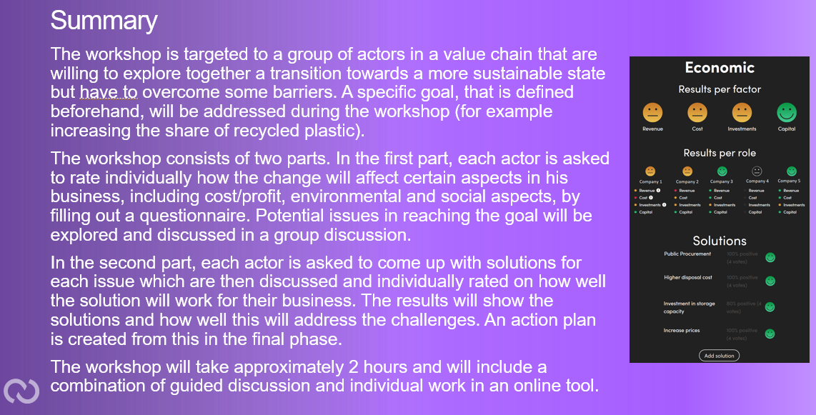
Figure 3 Summary of the workshop presented to the project group
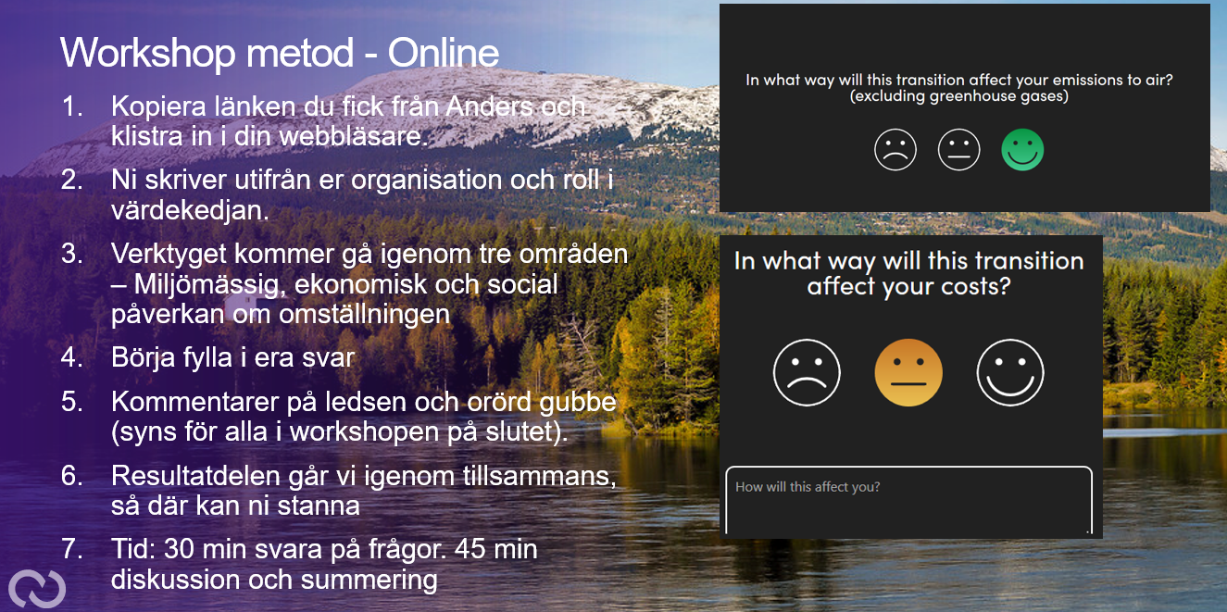
Figure 4 Overview of the workshop method presented to the project group during the workshop
After the workshop, the representatives from Chalmers Industriteknik sent out a survey link to the participants to evaluate the tool including the following four questions: 1) Was the tool valuable to support the discussions? 2) What part of the tool did you particularly like? 3) What can be developed in the tool? 4) Is the tool something you can consider using in your own organization? A summary of the results of this survey can be found below.

Results and discussion
Companies sometimes struggle with the transition to circular economy because such transition requires the involvement and cooperation of external parties, such as suppliers and customers. Collaboration between different actors in a value chain is needed to create a more sustainable value chain. Companies need to discuss openly what their opportunities and barriers are towards a more sustainable value chain, such that potential benefits can be shared and barriers can be overcome.
The tool and course material created in this project has as purpose to facilitate this discussion and encourages collaboration through a combination of guided discussion and individual work in the online tool. It targets any group of actors in a value chain that are willing to explore together a transition towards a more sustainable state but have to overcome some barriers. The tool, which is used during a two-hour workshop, highlights the opportunities and barriers of each actor for a certain pre-defined sustainability transition and allows participants to define and rate potential solutions on their feasibility. An action plan can be created from this in the final step of the workshop.
The tool is tailored to a value chain that want to change from a ‘linear’ flow towards a more ‘circular’ flow where products and components are reused or remanufactured or where material is recycled and used in the production process, although other sustainability transitions that involve multiple actors in a value chain are also possible. Examples of possible sustainability transitions that can be addressed with the tool are: changing to other for example biobased material, making the product more repairable or long-lasting, installing a closed-loop system where product ownership is retained by the companies, or making the product carbon neutral. The transition is evaluated on the economic, environmental, and social implications for each actor. There are no limitations regarding specific industries, any value chain considering a sustainability transition can use the tool.
The tool comes with a manual which describes the purpose of the tool, the underlying methodology, as well as a step by step description on how the tool can be used in a workshop. This should allow anyone to use the tool and run the workshop themselves. Alternative, Chalmers Industriteknik can be asked to run the workshop as facilitator.
It is anticipated (as the test runs showed) that the tool and workshop allow actors in a value chain to find solutions together that can take away the barriers withholding actors to collaborate and work towards a more sustainable state, and hence to create an action plan together to implement a more sustainable ‘closed-loop’ value chain. A selection of comments and feedback provided by the participants of the tests can be found below:
Jag gillade att “all fick lägga fram sin ståndpunkt innan diskussionen började, plus att sammanfattande förslag nådde omedelbar konsensus”, ”att skapa solutions baserat på resultat”, eller ”diskussion för att hitta gemensamma lösningar”.
Comments on what could be improved did not so much refer to the methodology or the questions asked in the tool, but focused on the choice of color and font in the tool, e.g.
“lite större font och kanske lite annat än färg”, ”kanske att man skriva en kommentar om man är positiv också”, ”ingen synpunkt”, ”utformning av val för solutions”.

Conclusion and next step
The tool and its manual are ready for dissemination and can be disseminated via the Re:Source webpage. This should allow anyone to use the tool in a workshop themselves, but Chalmers Industriteknik can also be asked to run the workshop as facilitator if that is preferred.
Chalmers Industriteknik has many projects around circularity and sustainability and we have the intention to use the tool where appropriate. For example, we are discussing the possibility to use the tool in another Re:Source project already early next year (i.e. Repipe), and have been asked about the tool by a customer of the graphene group at Chalmers Industriteknik and by Västsvenska Kemi och Materialklustret. The tool will be further be promoted at the Circular Material Conference in Gothenburg in September 2020. We further discussed the possibility of a follow-up project to boost the dissemination of the tool further via webinars and breakfast seminars.
As the test cases has shown, the ‘sustainability transition’ tool developed in this project help actors in a value chain to discuss potential circular material value chains in an open way such that the position of each actor in the circular value chain is better understood and that solutions that work for all partners can be found. It is anticipated that any industry considering a more circular material flow can benefit from using the tool to find collective action and move together towards a circular economy.
As mentioned above, the tool will be further promoted and disseminated in 2020 and Chalmers Industriteknik will be available for any request regarding the running of the workshop at any specific value chain.

Communication
We discussed with Re:Source on when to present the SVCO project on the Re:Source day. Re:Source suggested to present it at a meeting next year rather than this year. The project will further be presented at the Circular Materials Conference in September 2020.
The tool itself together with a manual is ready for dissemination and can be dissemination to Re:Source projects as well as other value chains when requested.

References
The ‘Sustainable Transition’ tool can be found here: https://svco-5e4ac.web.app/

TNO (2019). Energy transition value case methodology manual for facilitators. TNO report 2019 R10127.
Dittrich et al. (2015a). The value case methodology. Available at: publications.tno.nl/publication/34614766/c3hDrW/dittrich-2015-value.pdf
Dittrich et al. (2015b). A value case approach for analyzing goal alignment in multi-stakeholder networks: the case of sustainable product manufacturing in the electronics industry. Available at: https://www.researchgate.net/publication/281411042_A_Value_Case_Approach_for_Analysing_Goal_Alignment_in_Multi-Stakeholder_Networks_The_Case_of_Sustainable_Product_Manufacturing_in_the_Electronics_Industry

Attachments
Attachments that will be send in separate:
- Manual to the ‘sustainability transition’ tool.
- Questionnaires Mistra closing the loop projects.
- Administrative attachment to this final report
- Financial end report Energimyndigheten
- Project monitoring excel file Re:Source

Projects were selected from the list of ongoing Re:Source projects based on their project length (more than one year), number of partners involved and how close the project was to the end date. The list with selected projects was created in dialogue with Re:Source.

